DataFlowDiagram

LaptopDelivered
Date | 29September2026
Team ID | SWTID-2026-7796
Project Name | Streamlining IT Procurement: Automating Standard Laptop Orders with Flow Designer
MaximumMarks | 2Marks

DataFlowDiagram
Create a Data FlowDiagram (DFD) to showhowdata moves through your system - between externalentities, processes, and datastores. Usethesymbol legendbelowasaguide.

DFDSymbolLegend
Symbol | Name | Description
Oval/Rounded shape | ExternalEntity | A person, organization, or system outside the project that sends or receivesdata(e.g.,User,HardwareTeam).
Rectanglewith numbered header | Process | An activity that transforms incoming data into outgoing data (e.g., ValidateRequest,GenerateTask).
Rectangle(solidﬁll,no number) | DataStore | A place where data is held for later use (e.g., Request Table, Catalog TaskTable).
Labeledarrow | DataFlow | The movement of data between entities, processes, and data stores, labeledwithwhatdataisbeingpassed.
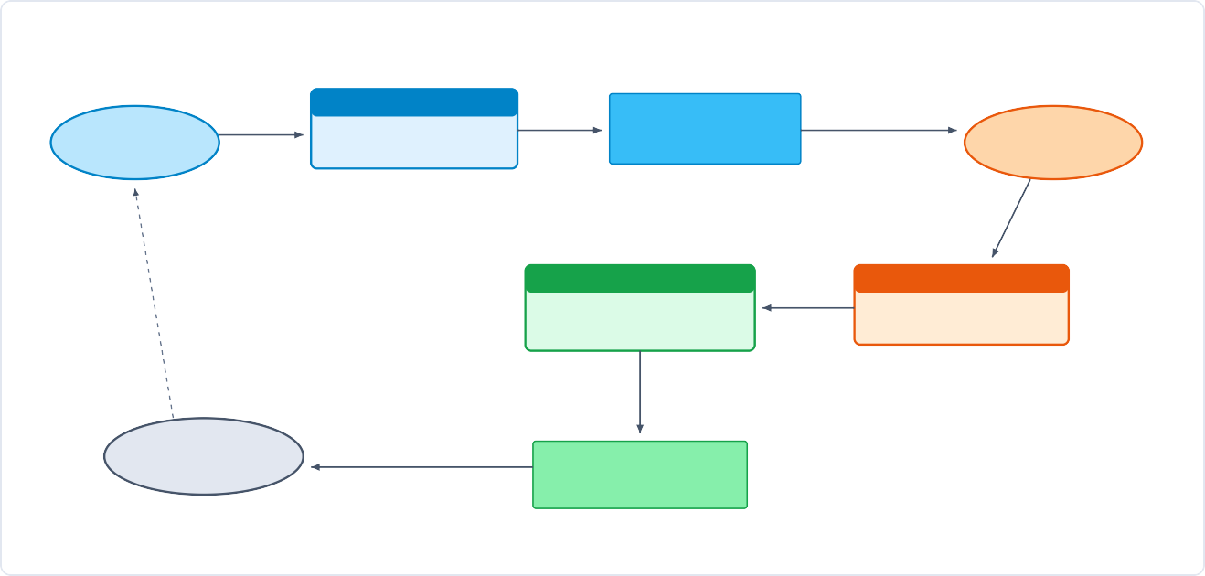SystemDataFlowDiagram
1.0OrderPlacement
LaptopRequest
RecordRITM
EndUser
ServiceCatalogOrder
RequestDatastore
[sc_request/sc_req_item]
ApprovalRequired
Approver
(Manager)
Decision(Approve)
3.0FlowDesignerTrigger
2.0Approval Processing
TriggerCondition
SpawnCatalogTask
Auto-populateshortdesc&group
Verify&SetState:Approved
InsertSCTASK
HardwareTeam
(Conﬁguration)
AssignTask:Hardware
CatalogTaskStore
[sc_task-SCTASK0010001]

